Networks / PCA / connectedness: GBPUSD and NZDUSD
Method 28 / pair slice of eight-major system / Alpari D1 full available history

Study setup
Logical pair: GBPUSD , NZDUSD
Broker symbols: GBPUSD_i , NZDUSD_i
Snapshot: 2026-11-03_majors_alpari_D1
Timeframe: D1
Matched return window: 1999-01-05 to 2026-11-02 (UTC bar dates)
Matched return count n: 7203
System panel n: 7127
Dropped unfinished last bar dated 2026-11-03 UTC after a tick-volume check against the prior complete day.
VAR lag (BIC): 1; GFEVD horizon H=10
System TCI: 54.0425
Complete matched rows (Excel): GBPUSD-NZDUSD_Network_D1.xlsx

Method carried forward
Three system-level tools on the eight-major daily log-return panel. (1) Network distance d_ij = sqrt(2*(1-rho_ij)) from Pearson correlation. (2) PCA eigenvalues of the correlation matrix R (R v = lambda v). (3) Diebold-Yilmaz total connectedness index (TCI) from a VAR with generalised forecast-error variance decomposition (GFEVD), horizon H=10; lag order chosen by BIC with maxlags=10. TCI = 100 * sum_{i!=j} theta_tilde_ij / N after row-normalising GFEVD shares. Pair reports show d_ij, rho_ij, and the directed pair spillover shares from the system theta_tilde matrix. Edges and TCI are not trading signals.

Pair results
Pearson rho: 0.532783
Network distance d_ij: 0.966661
theta_tilde[GBPUSD->NZDUSD] (row GBPUSD, col NZDUSD): 0.107822
theta_tilde[NZDUSD->GBPUSD] (row NZDUSD, col GBPUSD): 0.101356
PCA lambda_1: 3.817794
PCA variance share PC1: 0.477224

Conclusion
For GBPUSD-NZDUSD: d_ij=0.9667 from rho=0.5328. Pair spillover shares 0.1078 / 0.1014. System TCI=54.04. Not a trading signal.

Pair charts
Daily closes

Daily log returns
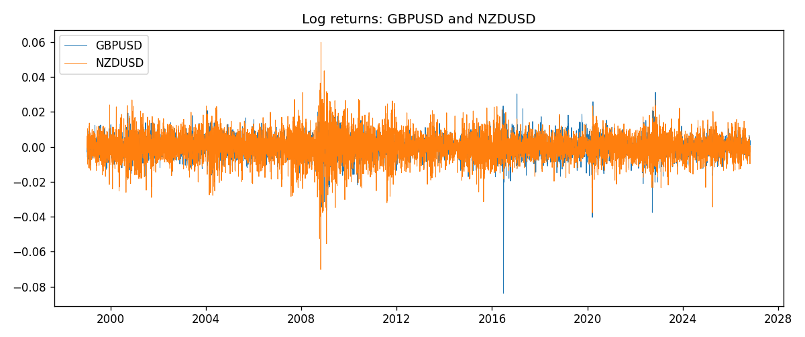

System charts (shared)
Correlation matrix

Distance matrix

PCA eigenvalues

GFEVD theta_tilde


Data report
First 15 matched rows
time | GBPUSD_log_return | NZDUSD_log_return
1999-01-05 | -0.0028966287 | -0.0018597736
1999-01-06 | -0.00060452184 | 0.0020455609
1999-01-07 | -0.002118709 | 0.0062963171
1999-01-08 | -0.0058954193 | -0.00055396548
1999-01-11 | -0.0056851331 | 0.010290425
1999-01-12 | 0.0022657001 | -0.0053157489
1999-01-13 | 0.0091330396 | -0.0099742238
1999-01-14 | 0.0019376331 | -0.00018564931
1999-01-15 | -0.0017558204 | -0.00074294208
1999-01-18 | 0.0012112405 | -0.0018597736
1999-01-19 | 0.0018745281 | 0.0018597736
1999-01-20 | -0.0049053846 | 0.0040793678
1999-01-21 | 0.0031518998 | 0.0040627941
1999-01-22 | 0.0024781662 | -0.012051689
1999-01-25 | 0.0012066366 | -0.0035504102
Last 15 matched rows
time | GBPUSD_log_return | NZDUSD_log_return
2026-10-13 | 0.0036434319 | 0.0047326165
2026-10-14 | -0.0049164679 | -0.0037306483
2026-10-15 | 0.0065976411 | 0.0047634855
2026-10-16 | 0.0037592051 | 0.0057501001
2026-10-19 | -0.0017500314 | 0.0018917133
2026-10-20 | 0.0055923442 | 0.0037199341
2026-10-21 | 0.0012476328 | 0.0030923331
2026-10-22 | 0.00022396082 | -0.0033035227
2026-10-23 | -0.0021146949 | 0.0030929853
2026-10-26 | -0.0024340661 | -0.0028993932
2026-10-27 | -0.0023648393 | -0.00026399852
2026-10-28 | 0.0015771808 | -0.0097283914
2026-10-29 | 0.0035881935 | 0.00062190714
2026-10-30 | 0.0013450605 | 0.00019537668
2026-11-02 | 0.0010971256 | -0.0025962955

